Web tech Assignment – 2018

# Hrishikesh V Section C, PES1201700276

# Prithvi Vasanth Section C

# Ravendra Singh Section C

## Project: An informational website focusing on recent events of various sports

# Objective

The website “Sports Network” is a standard sports news website which contains the latest goings on of various sports. As of now, the website includes topics on basketball (NBA), Soccer and Cricket. This website is intended to mimic sites such as ESPN.

The main objective is to design an interactive website for sports lovers.

# Structure

The website mainly uses CSS and javascript to handle front end. The backend is handled using php. Most of the pages contain a slideshow featuring relevant photos for the respective sports. This slideshow is designed with CSS and Javascript, wherein the picture “Slides” with the click of a button.

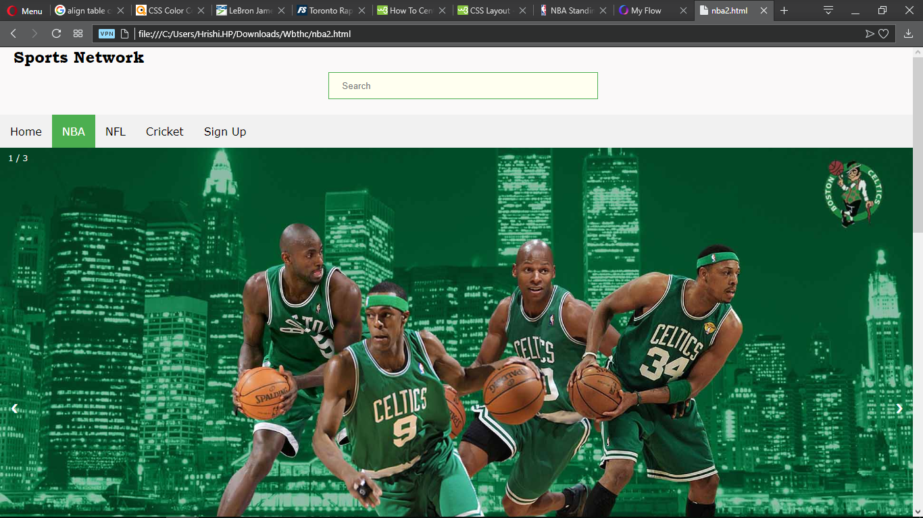

The navigation bar is an unordered list displayed as an array of blocks, with an option to change color on hover.

Most of the front end makes heavy use of CSS to get a colorful webpage

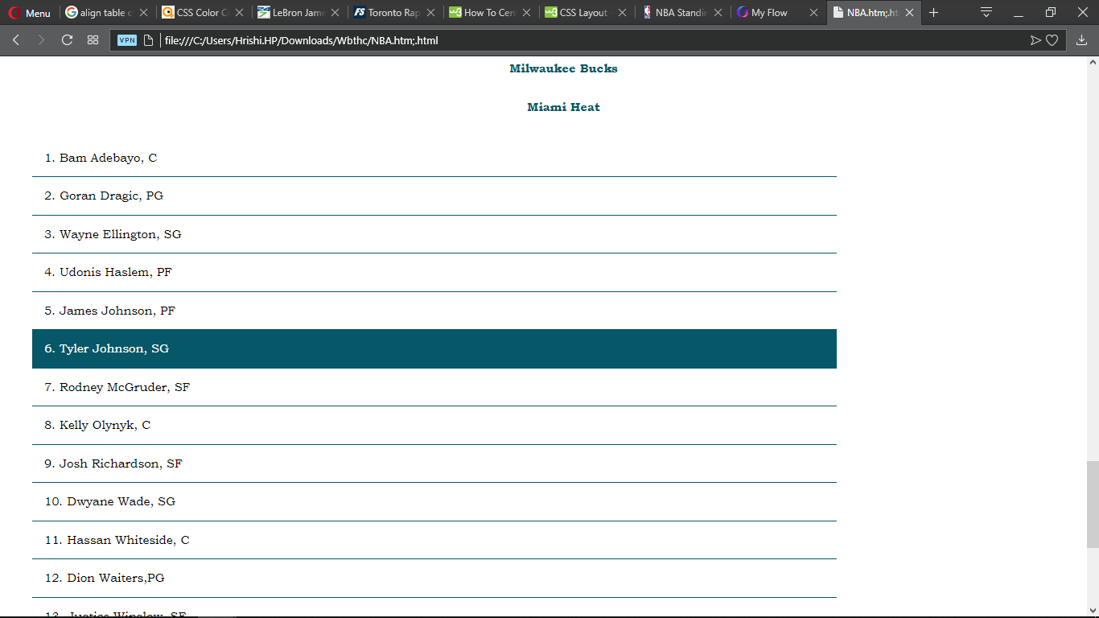

Javascript is used to hide and show div elements to conserve space on the site. The onclick event is used to trigger a function which in turn displays a div element enclosing a collection of html tags.

# Functionality

The frontend functionality includes:

1. The ability to navigate through multiple pages using a navigation bar
2. An onclick show/hide option to save webpage space.
3. Heavy use of CSS to make the website look more impressive
4. A sign up sheet to take user preferences

The backend functionality includes:

1. Using php to store user data taken in through the sign-up page
2. Displaying relevant webpages preferred by the user

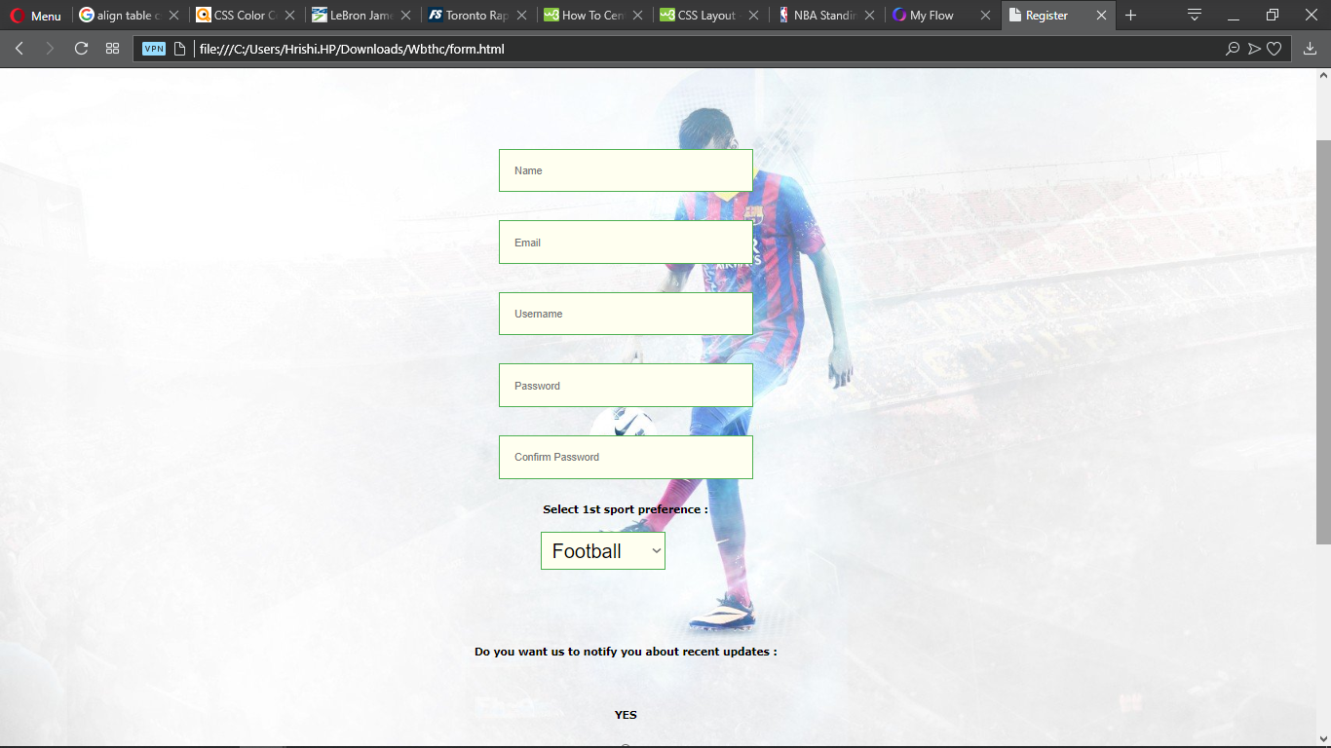

# Technologies used

1. HTML
2. Javascript
3. CSS
4. Php